Project Title:
The Secret Life of Transistors
Aims:
- Understand the physics and of BJT and MOSFET transistors
- Understand the characteristics and operation of these transistors
- Create logic gate circuits using transistors
- Build a functional half-adder by combining logic gates made with transistors.
- Construct a 4-bit adder, by combining our half-adder with other groups.
- Create and record a presentation on the fundamentals of BJTs and MOSFETs aimed at a non-technical audience.
Scope:
- To create a research document on semiconductor fundamentals, PN Junctions, NPN vs PNP Transistors, and MOSFETs
- To develop research in depth enough such that it can fill 5 slides of a 3-minute presentation
- To build a functional half adder using one type of transistor
- To use our half adder to complete a full adder and 4-bit adder with the help of other group's half adders
SMART Objectives:
SMART Objectives | Work Package(s)
Establish a team charter, including key roles, team objectives and corresponding tasks with deadlines, and norms in working environment by the end of Day 1 | WP1
Ensure project documentation is complete, confirmed and accessible between team members, by Day 4, 11:00am for the Audit test | WP1  WP2
Conduct initial research on BJTs and MOSFET operating principles, and their input and/or output characteristics, complete by Day 2, 12:15pm. | WP3
Construct functional circuits to test the relevant characteristics of BJTs and MOSFETs, compiling results as plots into a single document by the end of Day 3 | WP4
Construct a functional half-adder circuit by the end of Day 4, ensure its compatibility to make a full-adder circuit, verify their operation against the truth table, complete by the end of Day 4. | WP5
Integrate the circuit compatibility by creating a 4-bit adder using 2 chained full-adders by Day 5, 10:15 am | WP5
Create, record and upload an individual presentation explaining the fundamentals of transistors in three minutes, by 12pm on Day 5. | WP6

Work Packages:
WP1 – Project Management
Aim: Establish the team structure, allocate responsibilities, plan the schedule and manage project progress.
Tasks:
- Establish team charter: agree on the team’s purpose, expectations and working arrangements
- Delegate tasks:
- Create a skills matrix to identify the strengths and weaknesses of group members
- Distribute tasks equally, using the skills matrix as guidance
- Create a Gantt chart (using the work packages and objectives):
- Determine the dependencies of each task to establish their order
- Communicate with team members to estimate the duration of each task
- Identify the critical path, and any slack time. Optimise resource allocation and parallelise tasks accordingly
- Manage uncertainty and project risks by adding buffers where necessary
Deliverables:
- D1) Creation of a team charter that team members adhere to
- D2) Completion of tasks by the correct people according to skill matrix
- D3) Creation of a Gantt chart that is closely followed throughout the project

WP2 – Quality Management System
Aim: Perform well in the QMS audit
Tasks:
- Create a folder tree according to the ISO 9001 QMS
  - Quality Documents
    - Quality manual
    - Procedure
    - Forms
  - Quality control
  - Engineering
  - Operations
  - Purchasing
  - Sales/Customer service
  - Human Resources
  - Documents gallery
- Create a document that explains the naming of all files. It should capture:
  - Version control
  - Easy to find documents
  - Naming convention
- An excel spreadsheet of all the files in the QMS and their location placed in the “documents gallery” folder of the QMS
- Traceability matrix which captures the Design and Development of the product.
Deliverables:
D1) A functional QMS file hierarchy
D2) Document outlining file naming structure
D3) File Location Spreadsheet
D4) D&D Matrix

WP3 – Transistor Research
Aim: To gain a solid understanding of transistor physics and structure through background research.
Tasks:
- Semiconductor research
  - Why are semiconductors more useful than a simple conductor?
  - How can the conductivity of a semiconductor be deliberately changed?
  - How does doping a semiconductor affect its charge carriers?
- PN Junction research
  - What materials might be used for the P and N-type regions?
  - Why are depletion regions found at the interface of PN junctions?
  - How do PN junctions behave under forward and reverse bias? Why is this helpful for transistor operation?
- NPN vs PNP transistors
  - What are the different use cases for NPN and PNP transistors?
  - How do the doping concentrations and physics dimensions of each region differ and why?
  - How does the physical structure and doping of a BJT allow a small base current to control larger collector currents?
  - What are the operating modes of a BJT? How do they differ and what are their use cases?
- MOSFET research
  - What important device characteristics are used to classify the performance of a MOSFET? Why are they important?
  - What advantages and disadvantages do MOSFETs have over BJTs?
  - How does a MOSFET utilise an electric field to control current?
Deliverables:
- D1) Research Document containing 4 sections: Semiconductor, PN Junctions, NPN vs PNP, and MOSFETs

WP4 – Transistor Investigation
Aim: To determine crucial characteristics of BJTs and MOSFETs.
Tasks:
- Study BJT Input Characteristics
  - Create this circuit:
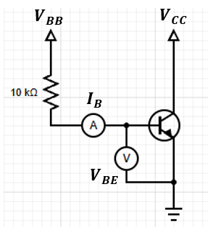
  - Set $V_{CC}$ = 2.5V
  - Adjust $V_{BB}$ from 1V to 15V, measuring $V_{BE}$ and $I_{B}$ at each voltage
  - Repeat this for 2 more $V_{CC}$ Voltages
  - Plot $I_{B}$ vs $V_{BE}$
- Study BJT Output Characteristics
  - Create this circuit:
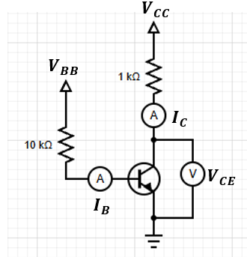
  - Use a value of $V_{BB}$ that gives $I_{B }≈10 μA$
  - Adjust $V_{CC}$ such that $V_{CE}$ has a range of values from 0.1V to 5V (Have a higher density of points for $V_{CE}$ < 1V to see saturation)
    - For each voltage, measure $I_{C}$
  - Repeat for 2 more values of $I_{B}$
  - Plot $I_{C}$ vs $V_{CE}$
- MOSFET Output Characteristics
  - Create this circuit:
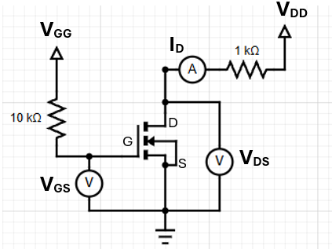
  - To measure drain characteristics:
    - Keep $V_{GS}$ constant at 4V by varying $V_{GG}$
    - Vary $V_{DS}$ by 0.2V, measuring $I_{D}$ until the current becomes constant
    - Once constant, vary $V_{DS}$ by 1V up until 15V
    - Repeat for two more $V_{GS}$ Voltages
    - Plot $V_{DS}$ vs $I_{D}$
  - To measure transfer characteristics:
    - Keep $V_{DS}$ constant at 4V by varying $V_{GG}$
    - Vary $V_{GS}$ by 0.2V, measuring $I_{D}$ until the current becomes constant
    - Once constant, vary $V_{GS}$ by 1V up until 15V
    - Repeat for two more $V_{DS}$ Voltages
    - Plot $V_{GS}$ vs $I_{D}$
    - Find the maximum transconductance by finding the maximum gradient of the plot
Deliverables:
- D1) BJT Input Characteristics $I_{B}$ vs $V_{BE}$ Plot
- D2) BJT Output Characteristics $I_{C}$ vs $V_{CE}$ Plot
- D3) MOSFET Drain Characteristics $V_{DS}$ vs $I_{D}$ Plot
- D4) MOSFET Transfer Characteristics $V_{GS}$ vs $I_{D}$ Plot
- D5) MOSFET maximum transconductance

WP5 – Logic Circuits
Aim: To understand the role of transistors in logic and build functioning logic circuits.
Tasks:
- Logic circuits: Build individual logic circuits and test their functionality for each combination of inputs e.g.
NOT:
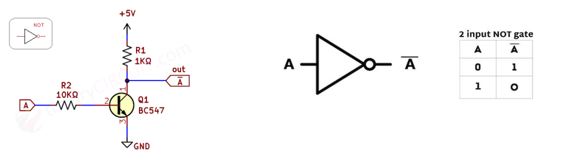
- Half adder: Combine these logic gates to create a half adder and test its functionality for each combination of inputs
- Full adder: Combine the half adder with other groups to create a full adder and test it.
- 4-bit adder: Combine more adders to create a 4-bit adder. Test if it can successfully add two 4-bit binary numbers
Deliverables:
- D1) Truth tables of the experimental logic gates: NOT, AND, OR, XOR are correct.
- D2) Truth table of experimental half adder is correct.
- D3) Truth table of experimental full adder is correct.
- D4) Truth table of experimental 4-bit adder is correct.

WP6 – Project Presentation
Aim: Individually create and successfully deliver a three-minute presentation on transistors.
Tasks:
- Create a slideshow no more than 5 slides long to present an overview of a transistor structure, characteristics and application to a non-technical audience.
  - Use charts, graphs, or tables to present data in a clear, visually appealing way. Ensure data elements are labelled to make it easy to understand
  - Creating Diagrams and Flowcharts: use diagrams to explain complex ideas, especially if steps are involved.
  - Arranging elements and White space: Arrange text, images, and data on each slide thoughtfully, ensuring enough white spice for a clean, uncluttered appearance. White space around each element will make your presentation feel more organised and allow each section to stand out.
  - Readability: use consistent font sizes and styles and avoid overloading slides with text.
- Record yourself presenting this slideshow. You should focus on:
  - Speaking clearly, at a well-paced speed, with an appropriate volume and confidence
  - Avoid filler words and sounding unsure
Deliverables:
D1) Slideshow on transistors that can be understood by a non-technical audience available on Mahara.
D2) Recording of a confidently delivered presentation on transistors available on Mahara.

Milestones:
Work Package | Description | Target date and time  (WB: 2/11)
WP1 | Team charter, skills matrix and Gantt chart complete | Monday 17:15
WP2 | QMS Standard implemented | Monday 17:15
WP3 | All four sections of the research document completed | Wednesday 15:15
WP4 | All plots created and maximum transconductance | Thursday 17:15
WP5 | All logic gates' circuits verified against their truth tables. | Thursday 17:15
WP6 | Transistor presentation submitted | Friday 13:00

